

**Final Project Documentation**

**Members:**  
Saif Majid Khan – 57114

Haider Ali – 53109

Section: CS4-1

Dated: 5/10/2025

**Instructor:**  
Sir. Raja Jalees

**Session:** Spring 2025

**Subject:** System Analysis & Design

Riphah Internationaal University

Contents

1. Introduction: 5

A. Problem 5

B. Solution 5

C. Core Features 5

2. System Stakeholders & Requirements 6

A. University Administration 6

B. Faculty ( Professors & lecturers) 6

C. Students 6

D. Examination Controllers 6

E. IT and System Administrators 6

F. Regulatory Authorities 6

G. Investors & Sponsors 6

3. Elicitation Techniques Applied 7

Survey Questions 7

Open-Ended Questions: 7

Closed-Ended Questions: 7

4. Prioritizing Techniques 8

A. 100$ Technique: 8

B. MoSCOW Technique: 8

5. UML Diagrams 10

Use-Case Diagram: 10

Class Diagram: 11

Activity Diagram 12

State Diagram 13

Collaboration Diagram 14

Architecture Diagram 15

Sequence Diagram 16

Google Forms Link 18

GitHub Repo Link 18

1. Introduction:  
   The University Examination Management System is an online platform aimed at simplifying and automating the overall process of examinations in a university. It provides secure student authentication, scheduling of exams, conducting exams online, processing results, and performance reporting. It provides transparency, efficiency, and accuracy in managing exams and minimizes manual effort for administrators, examiners, and students. Providing role-based access and centralized data management, it is a secure solution for contemporary academic institutions.
2. Problem  
   Manually managing university exams tends to create inefficiencies like scheduling conflicts, late processing of results, and higher opportunities for errors. Conventional systems do not have automation and centralized control, and therefore students, examiners, and administrators find it challenging to get timely and accurate information. This leads to frustration, miscommunication, and additional administrative burden, ultimately impacting the entire examination process and academic integrity.

### Solution

The University Examination Management System provides an automatic, centralized system to meet these needs by simplifying the scheduling of exams, secure login, online conduct of exams, and quick processing of results. By making the entire examination process digital, it minimizes errors, reduces manual labor, and grants real-time access to exam data for students, examiners, and administrators. This system enhances clarity, efficiency, and accuracy, improving the overall examination process and maintaining academic integrity.

### Core Features

University Examination Management System provides an all-inclusive, centralized solution aimed at automating major examination operations. It features secure user authentication, simplified exam scheduling, online exam conduct with utmost ease, and quick generation of results. By converting these workflows into digital form, the system reduces human errors, minimizes administrative burden, and offers instant access to exam-related data for students, examiners, and administrators. This leads to greater transparency, increased efficiency, and consistent management of the entire examination cycle.

## 2. System Stakeholders & Requirements

### A. University Administration

* Oversee the examination process and ensure compliance with academic policies.
* Approve examination schedules and grading standards.
* Receive analytical reports on student performance and exam integrity.

### B. Faculty ( Professors & lecturers)

* Create and manage examination papers and grading schemes.
* Monitor and supervise examination sessions.
* Access student performance data and generate reports.

### C. Students

* Register for examinations through an online portal.
* Access examination schedules and guidelines.
* Receive examination results and performance analytics.

### D. Examination Controllers

* Manage examination logistics, including scheduling and invigilation assignments.
* Oversee the security and confidentiality of question papers.
* Handle academic misconduct cases and ensure fair examination practices**.**

### E. IT and System Administrators

* Ensure system uptime and data security.
* Implement access controls and authentication mechanisms.
* Provide technical support for faculty and students.

### F. Regulatory Authorities

* Ensure compliance with education standards and examination policies.
* Monitor audit trails of examination activities.
* Approve academic integrity measures and security protocols.

### G. Investors & Sponsors

* Provide funding for system development and upgrades.
* Monitor the system's performance and scalability.
* Assess potential returns on investment in education technology.

## 3. Elicitation Techniques Applied

* **Interviews:** Conducted with university administration, faculty, and students.
* **Surveys:** Distributed to students and faculty for feedback on exam management.
* **Observations:** Monitored examination procedures to identify inefficiencies.
* **Workshops:** Conducted brainstorming sessions to improve exam security measures.

### Survey Questions

### Open-Ended Questions:

* What are the biggest challenges you face with the current examination system?
* What do you think is the most stressful part of the examination process?
* What additional features would you like to see in an exam management system?
* What improvements would make the online exam registration process easier?
* If you have ever faced difficulties accessing your exam results, please describe your experience.
* What communication method do you find most reliable for receiving exam-related updates?
* In what ways do you think an online examination system could reduce stress for students?
* If given a chance, what feature would you add to enhance the security of online exam results?
* What issues have you faced with exam hall allocations, if any?
* Describe any past experience where an exam-related system failed to meet your expectations.

### Closed-Ended Questions:

* What are the biggest challenges you face with the current examination system?
* What do you think is the most stressful part of the examination process?
* What additional features would you like to see in an exam management system?
* What improvements would make the online exam registration process easier?
* If you have ever faced difficulties accessing your exam results, please describe your experience.
* What communication method do you find most reliable for receiving exam-related updates?
* In what ways do you think an online examination system could reduce stress for students?
* If given a chance, what feature would you add to enhance the security of online exam results?
* What issues have you faced with exam hall allocations, if any?
* Describe any past experience where an exam-related system failed to meet your expectations.

## 4. Prioritizing Techniques

### A. 100$ Technique:

|  |  |  |
| --- | --- | --- |
| Requirement | Stakeholder(s) | Priority (100$ Bill) |
| Exam scheduling and registration | |  | | --- | |  | | Students, Faculty | | 15$ |
| Secure question paper generation | Faculty, Admin | 12$ |
| Online examination capability | |  | | --- | |  | | Students, Admin | | 12$ |
| Plagiarism and cheating detection | Examination Controllers | 14$ |
| Secure database for exam records | IT Administrators | 10$ |
| Automated grading and result processing | Faculty | 10$ |
| Real-time analytics on student performance | University Admin | 8$ |
| Compliance with academic regulations | |  | | --- | |  | | Regulatory Authorities | | 7$ |
| Multi-factor authentication for access | IT Administrators | 6$ |
| Total |  | 100$ |
|  |  |  |
|  |  |  |

### B. MoSCOW Technique:

|  |  |  |
| --- | --- | --- |
| Requirement | Stakeholder(s) | MoSCoW Priority |
| Exam scheduling and registration | Students, Faculty | Must-Have |
| Secure question paper generation | Faculty, Admin | Must-Have |
| Online examination capability | Students, Admin | Must-Have |
| Plagiarism and cheating detection | Examination Controllers | Must-Have |
| Secure database for exam records | IT Administrators | Must-Have |
| Compliance with academic regulations | Regulatory Authorities | Must-Have |
| Automated grading and result processing | Faculty | Should-Have |
| Real-time analytics on student performance | University Admin | Should-Have |
| Multi-factor authentication for access | IT Administrators | Should-Have |

## 5. UML Diagrams

### Use-Case Diagram:

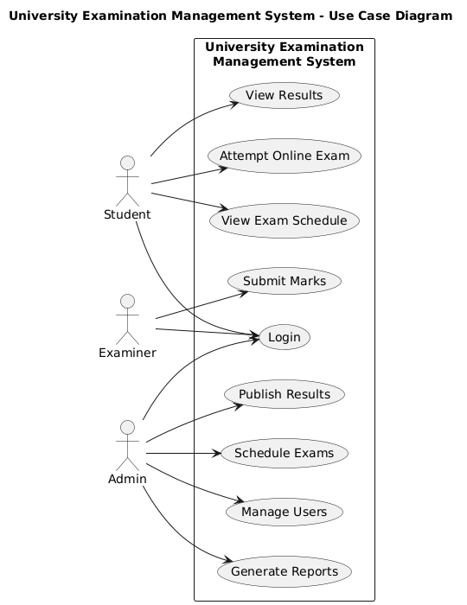

### Class Diagram:

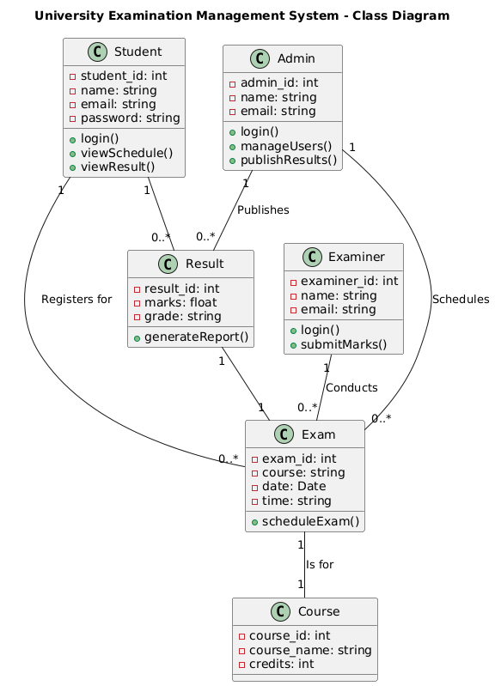

### Activity Diagram

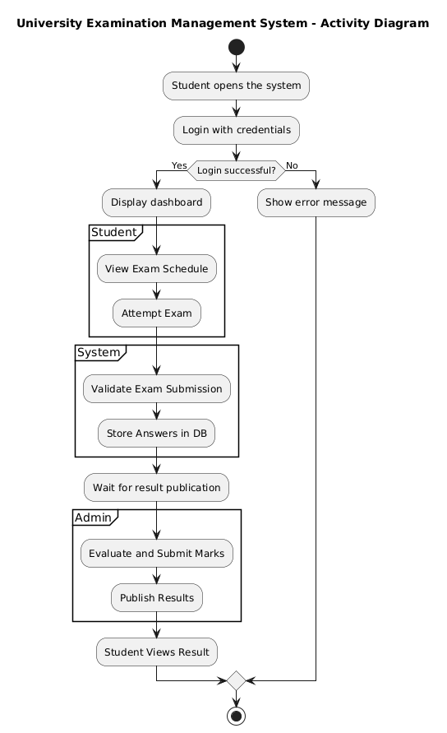

### State Diagram

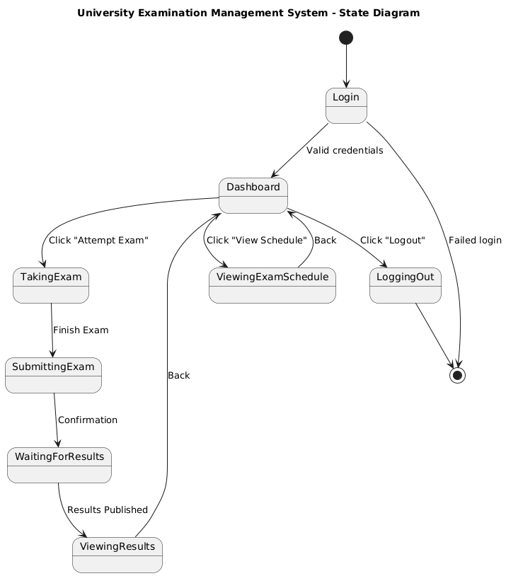

### Collaboration Diagram

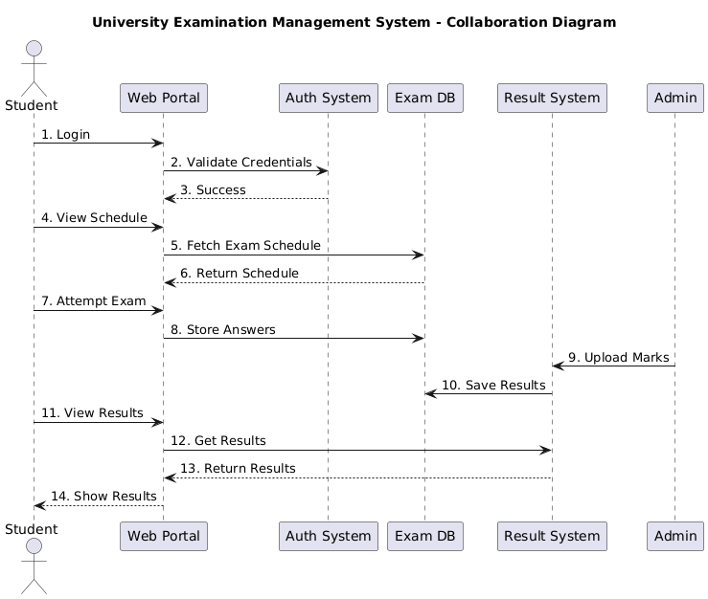

### Architecture Diagram

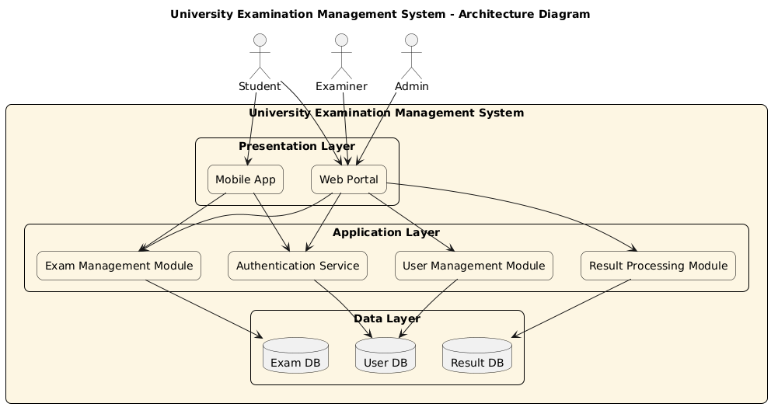

### Sequence Diagram

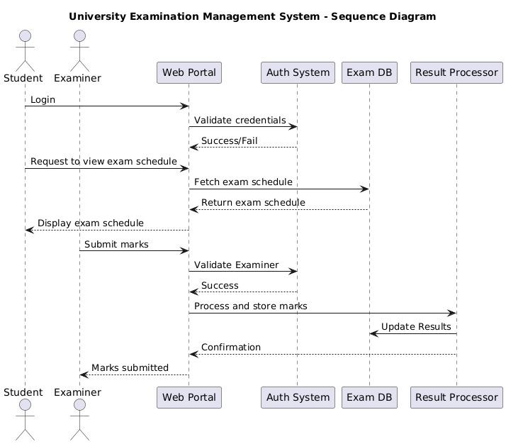

Survey Questions (Responses)   
Forms response chart. Question title: How do you usually register for exams?  
. Number of responses: 2 responses.

Forms response chart. Question title: How often do you check for exam-related updates?
. Number of responses: 2 responses.

Forms response chart. Question title: Would you prefer a centralized online portal for exam schedules, results, and guidelines?
. Number of responses: 2 responses.

# Google Forms Link

<https://docs.google.com/forms/d/16ULbeaWS6zlUND8_pQDEeQZxHmWcsKuI_dACniel7hQ/edit#responses>

# GitHub Repo Link

**https://github.com/saif01234567/System-Analysis-Design-Project.git**